1.

I don't have actual values for the DNS parameters (HostedZoneId and Name) in the "MyDNSRecordSet" resource, it is causing an error in CloudFormation.

So, I removed "MyDNSRecordSet" resource from the template

STACK CREATION

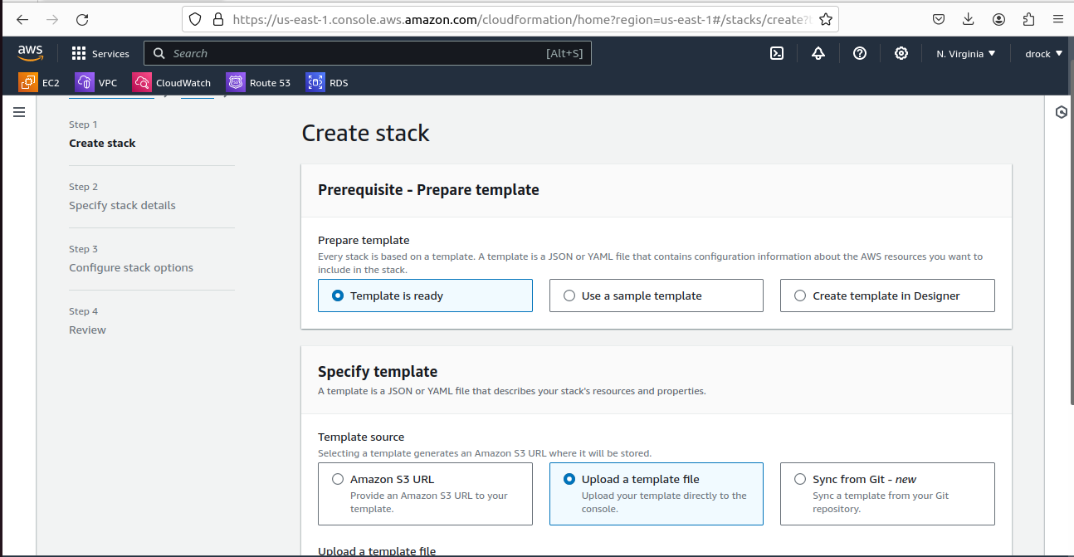
PICK DESIGNER TEMPLATE CREATED AND SAVED IN LOCAL FURTHER DETAILS BELOW

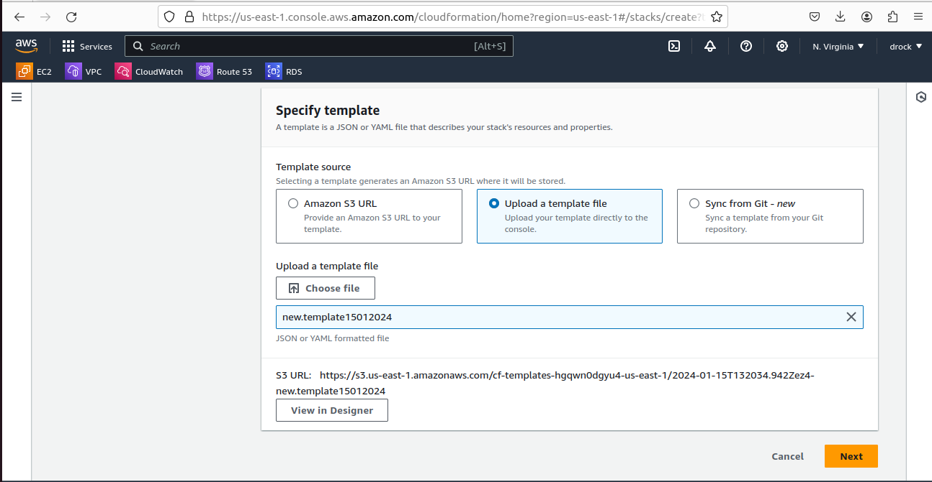

CLICK NEXT AND NAME THE STACK

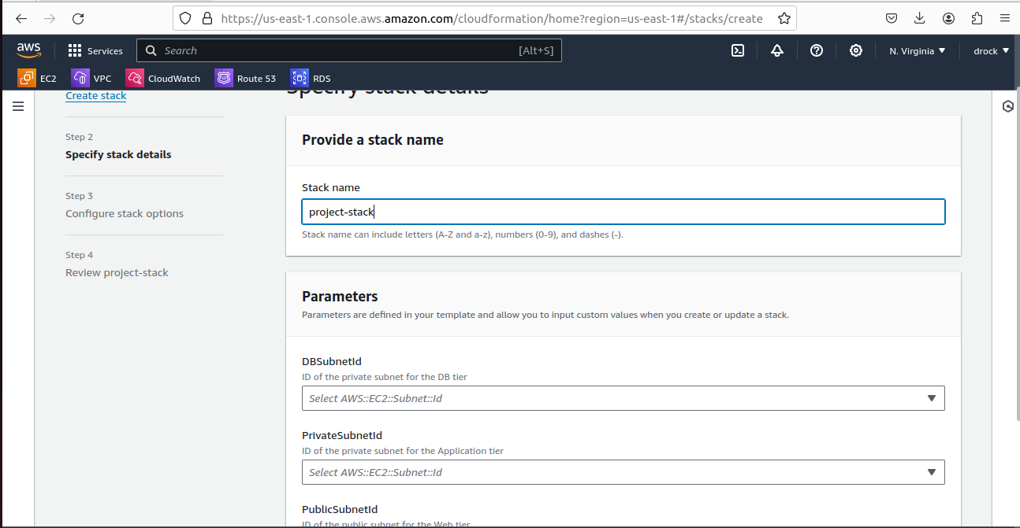

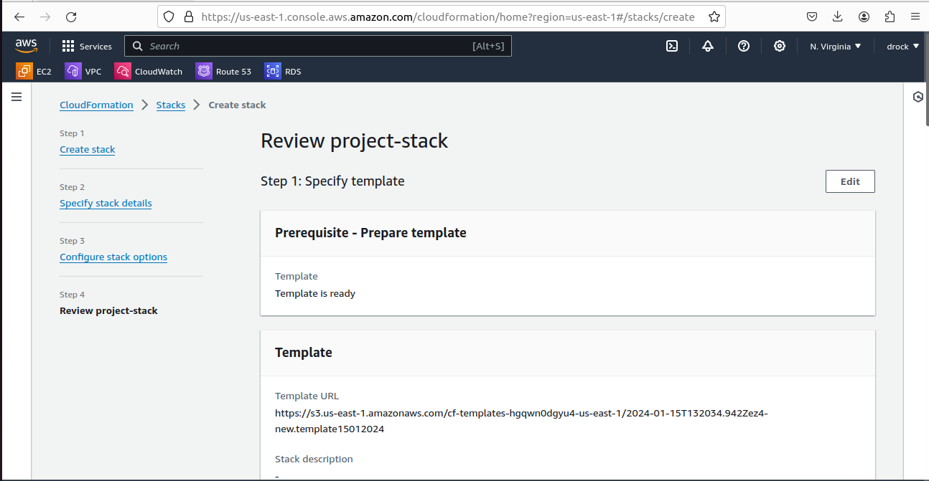

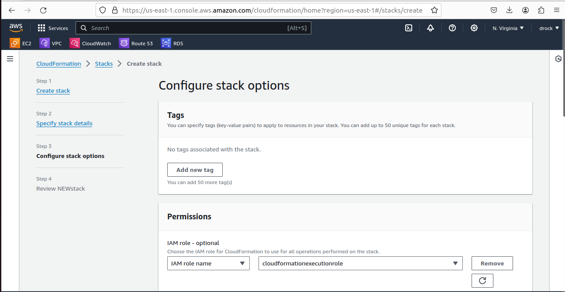
IAM role was created for the resource, with adequate permission.

CHOSEN PARAMETERS

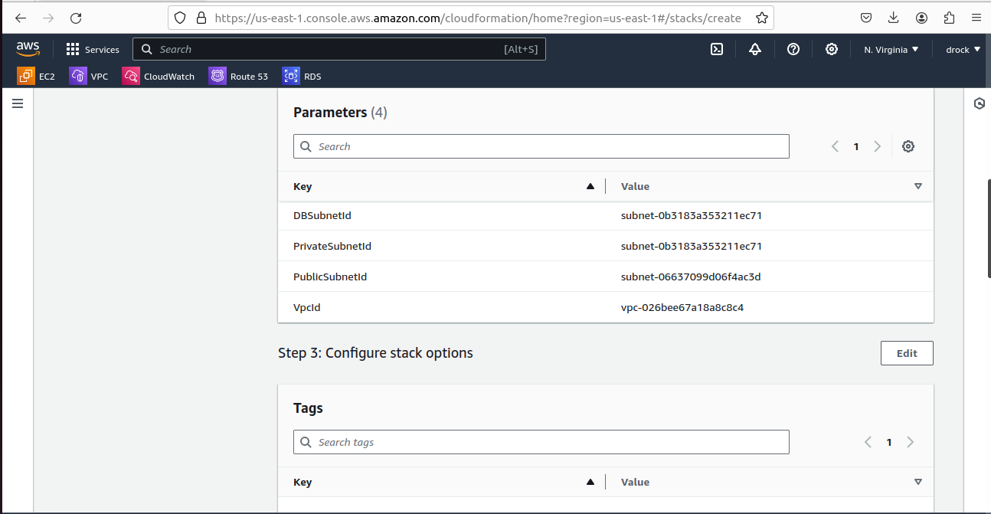

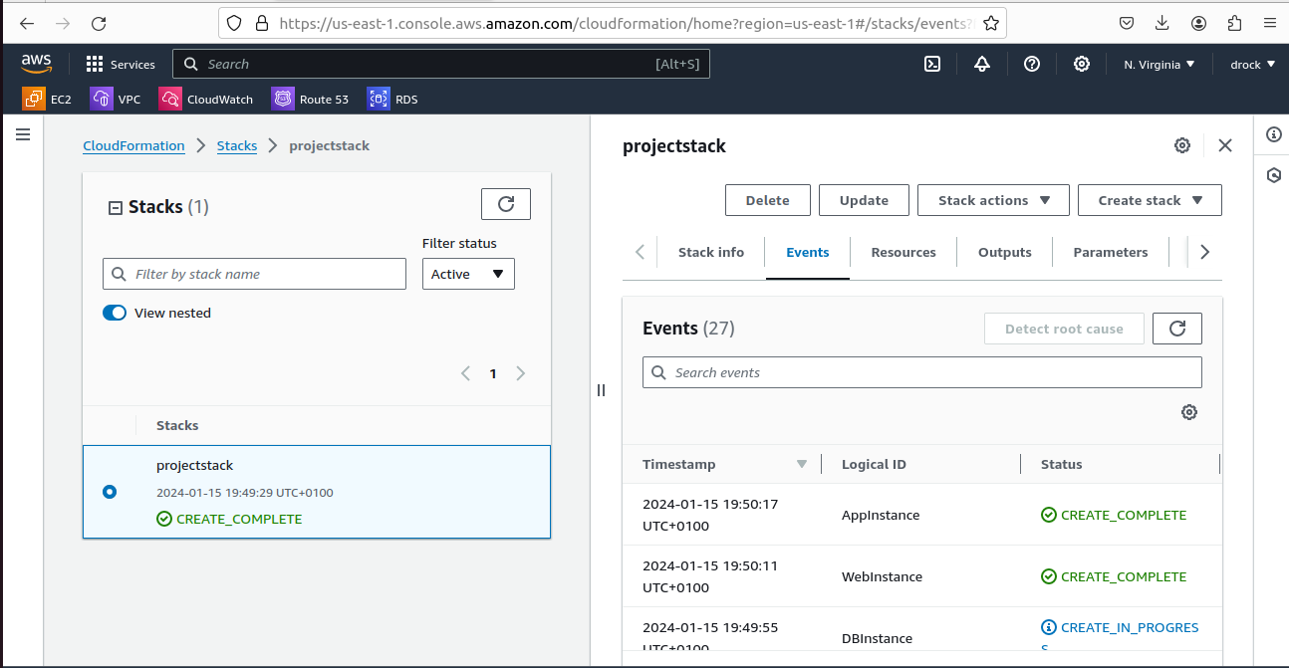
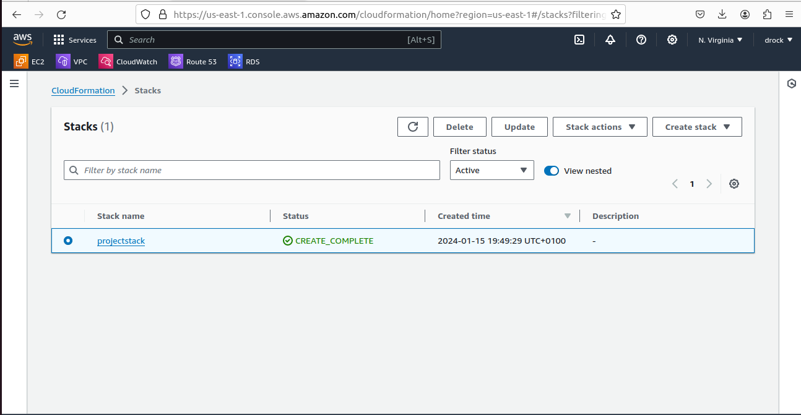

RDS CREATED
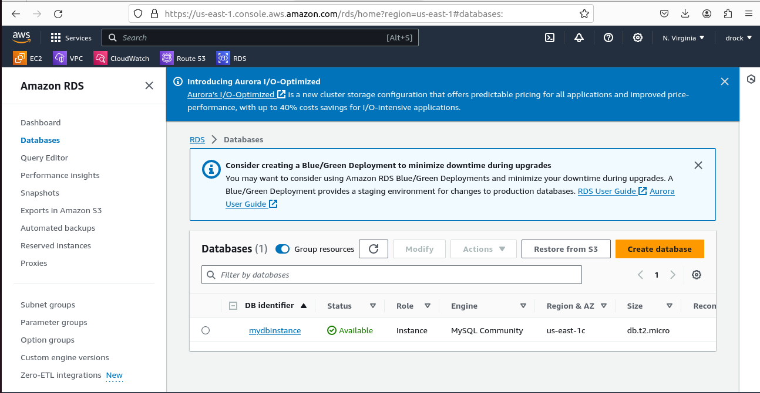

WEB AND APPLICATION INSTANCE CREATION
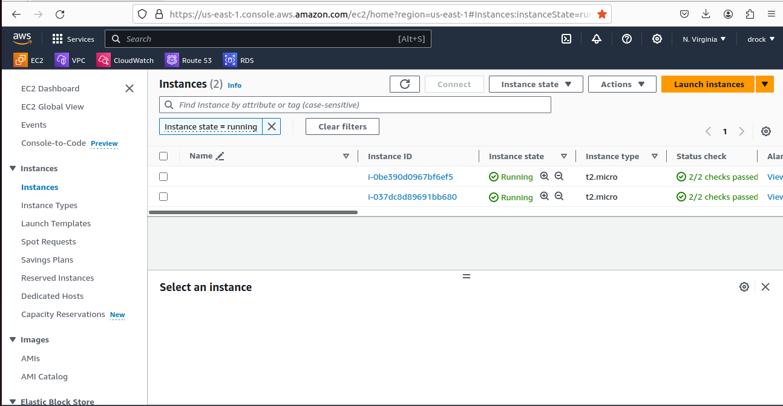

APPLICATION SERVER; WITH APPLICATION SECURITY SPECIFICATION

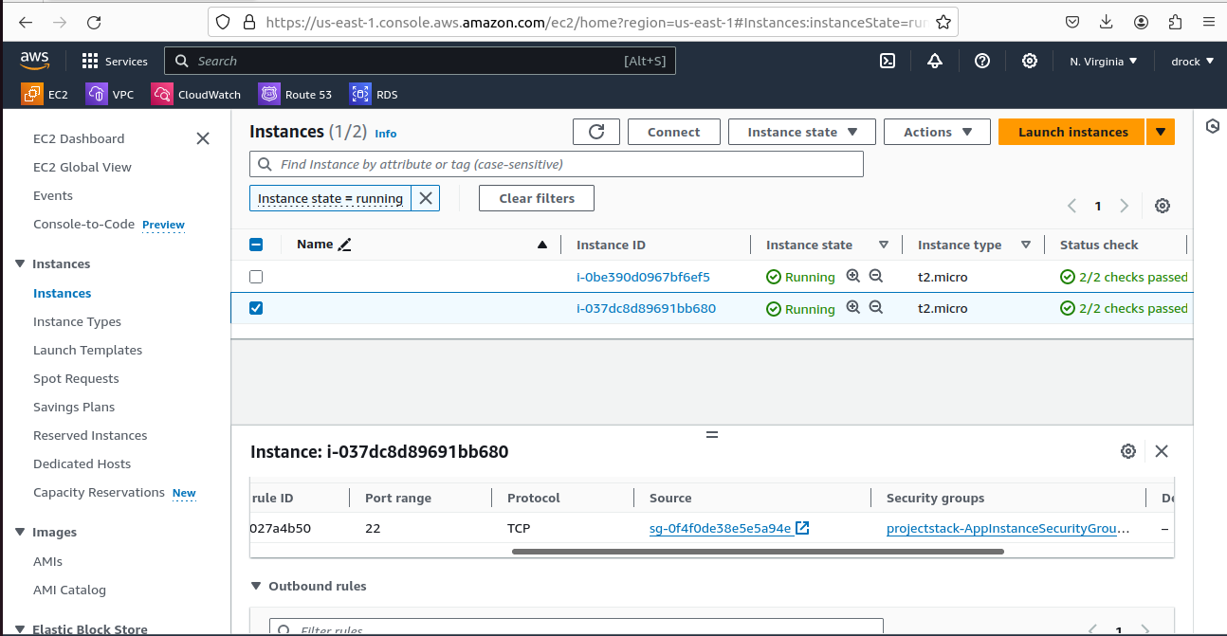

WEB SERVER WITH WEB SERVER SECURITY SPECIFICATIONS

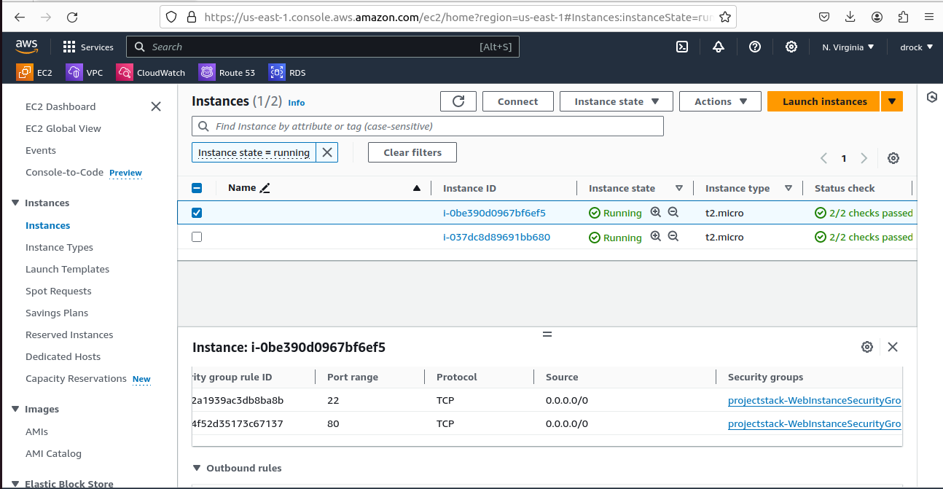

DETAILS OF WEBINSTANCE SECURITY GROUP ID

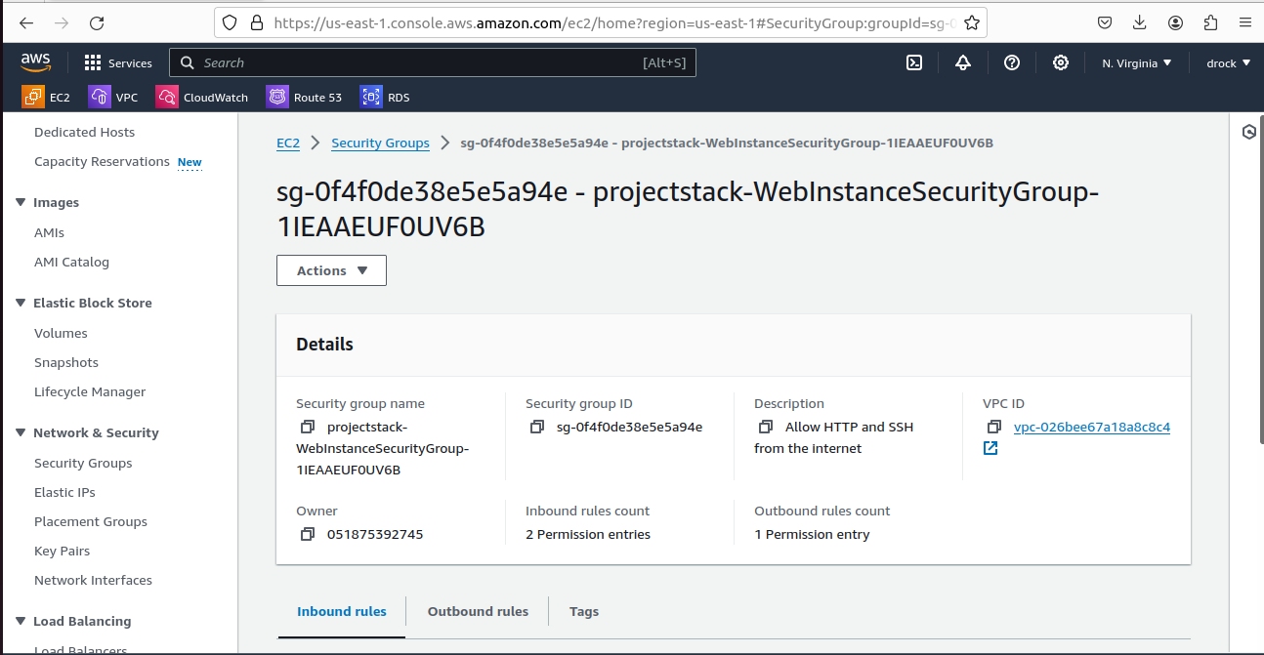

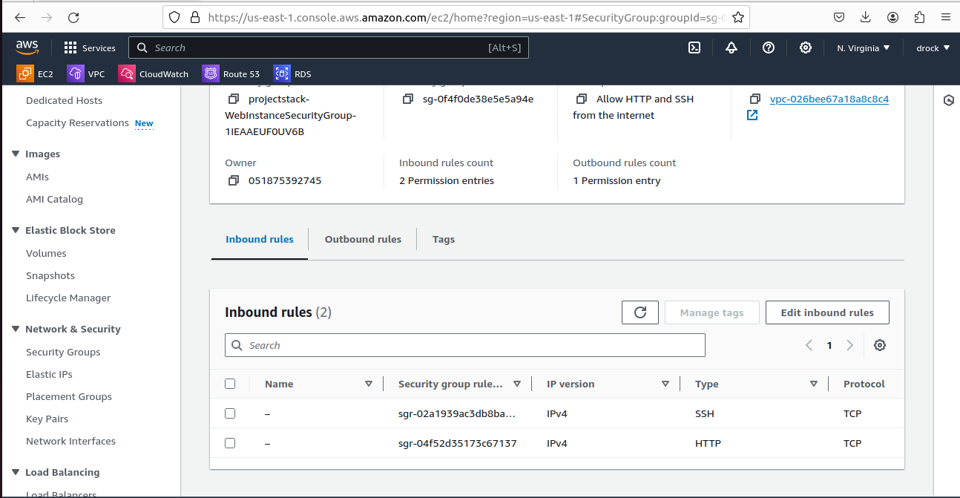

STACK DETAILS
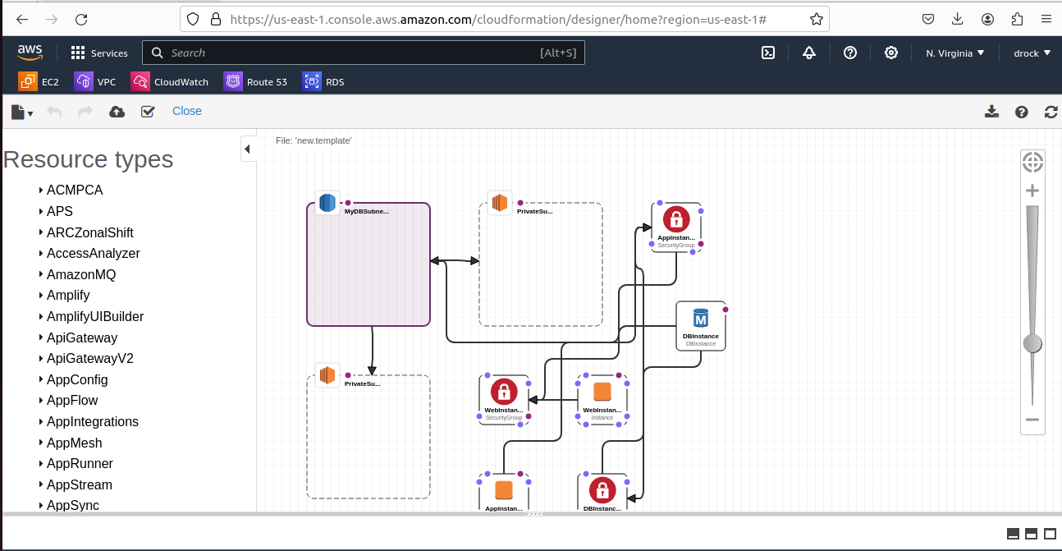
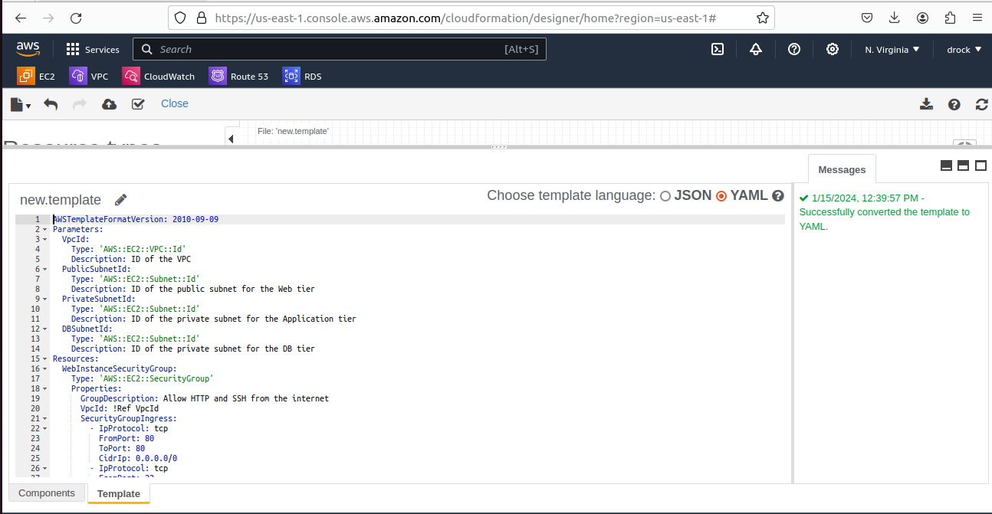

DETAILS OF THE YAML FILE
AWSTemplateFormatVersion: 2010-09-09
Parameters:
VpcId:
Type: 'AWS::EC2::VPC::Id'
Description: ID of the VPC
PublicSubnetId:
Type: 'AWS::EC2::Subnet::Id'
Description: ID of the public subnet for the Web tier
PrivateSubnetId:
Type: 'AWS::EC2::Subnet::Id'
Description: ID of the private subnet for the Application tier
DBSubnetId:
Type: 'AWS::EC2::Subnet::Id'
Description: ID of the private subnet for the DB tier
Resources:
WebInstanceSecurityGroup:
Type: 'AWS::EC2::SecurityGroup'
Properties:
GroupDescription: Allow HTTP and SSH from the internet
VpcId: !Ref VpcId
SecurityGroupIngress:
- IpProtocol: tcp
FromPort: 80
ToPort: 80
CidrIp: 0.0.0.0/0
- IpProtocol: tcp
FromPort: 22
ToPort: 22
CidrIp: 0.0.0.0/0
AppInstanceSecurityGroup:
Type: 'AWS::EC2::SecurityGroup'
Properties:
GroupDescription: Allow only SSH from the public subnet of Web Tier-3
VpcId: !Ref VpcId
SecurityGroupIngress:
- IpProtocol: tcp
FromPort: 22
ToPort: 22
SourceSecurityGroupId: !Ref WebInstanceSecurityGroup
DBInstanceSecurityGroup:
Type: 'AWS::EC2::SecurityGroup'
Properties:
GroupDescription: >-
Allow connection on port 3306 only from the private subnet of
Application Tier-4
VpcId: !Ref VpcId
SecurityGroupIngress:
- IpProtocol: tcp
FromPort: 3306
ToPort: 3306
SourceSecurityGroupId: !Ref AppInstanceSecurityGroup
WebInstance:
Type: 'AWS::EC2::Instance'
Properties:
ImageId: ami-0005e0cfe09cc9050
InstanceType: t2.micro
KeyName: newkey-virginia
SubnetId: !Ref PublicSubnetId
SecurityGroupIds:
- !Ref WebInstanceSecurityGroup
UserData: !Base64
'Fn::Sub': |
#!/bin/bash
# Your initialization script here
AppInstance:
Type: 'AWS::EC2::Instance'
Properties:
ImageId: ami-0005e0cfe09cc9050
InstanceType: t2.micro
KeyName: newkey-virginia
SubnetId: !Ref PrivateSubnetId
SecurityGroupIds:
- !Ref AppInstanceSecurityGroup
UserData: !Base64
'Fn::Sub': |
#!/bin/bash
# Your initialization script here
PrivateSubnet1:
Type: 'AWS::EC2::Subnet'
Properties:
VpcId: !Ref VpcId
CidrBlock: '172.31.96.0/24'
# Add other necessary properties

PrivateSubnet2:
Type: 'AWS::EC2::Subnet'
Properties:
VpcId: !Ref VpcId
CidrBlock: '172.31.112.0/24'
# Add other necessary properties

MyDBSubnetGroup:
Type: 'AWS::RDS::DBSubnetGroup'
Properties:
DBSubnetGroupDescription: My DB Subnet Group
SubnetIds:
- !Ref PrivateSubnet1
- !Ref PrivateSubnet2
# Add more subnets if needed
DBInstance:
Type: 'AWS::RDS::DBInstance'
Properties:
Engine: mysql
DBInstanceIdentifier: MyDBInstance
MasterUsername: admin
MasterUserPassword: adminpassword
AllocatedStorage: 20
DBInstanceClass: db.t2.micro
VPCSecurityGroups:
- !Ref DBInstanceSecurityGroup
MultiAZ: false
StorageType: gp2
DBSubnetGroupName: !Ref MyDBSubnetGroup
Outputs:
WebInstance:
Description: Public IP of the EC2 instance in the Web tier
Value: !GetAtt
- WebInstance
- PublicIp
AppInstance:
Description: Private IP of the EC2 instance in the Application tier
Value: !GetAtt
- AppInstance
- PrivateIp
DBInstance:
Description: DB Instance Endpoint of the RDS MySQL instance in the DB tier
Value: !GetAtt
- DBInstance
- Endpoint.Address

2.
Make sure when the development team deletes the stack, RDS DB
instances should not be deleted.

Here Deletion Protection under RDS is set to TRUE

The cloudformation Template :RDS DB INSTANCE (Deletion protection) is copied below:

AWSTemplateFormatVersion: 2010-09-09
Parameters:
VpcId:
Type: 'AWS::EC2::VPC::Id'
Description: ID of the VPC
PublicSubnetId:
Type: 'AWS::EC2::Subnet::Id'
Description: ID of the public subnet for the Web tier
PrivateSubnetId:
Type: 'AWS::EC2::Subnet::Id'
Description: ID of the private subnet for the Application tier
DBSubnetId:
Type: 'AWS::EC2::Subnet::Id'
Description: ID of the private subnet for the DB tier
Resources:
WebInstanceSecurityGroup:
Type: 'AWS::EC2::SecurityGroup'
Properties:
GroupDescription: Allow HTTP and SSH from the internet
VpcId: !Ref VpcId
SecurityGroupIngress:
- IpProtocol: tcp
FromPort: 80
ToPort: 80
CidrIp: 0.0.0.0/0
- IpProtocol: tcp
FromPort: 22
ToPort: 22
CidrIp: 0.0.0.0/0
AppInstanceSecurityGroup:
Type: 'AWS::EC2::SecurityGroup'
Properties:
GroupDescription: Allow only SSH from the public subnet of Web Tier-3
VpcId: !Ref VpcId
SecurityGroupIngress:
- IpProtocol: tcp
FromPort: 22
ToPort: 22
SourceSecurityGroupId: !Ref WebInstanceSecurityGroup
DBInstanceSecurityGroup:
Type: 'AWS::EC2::SecurityGroup'
Properties:
GroupDescription: >-
Allow connection on port 3306 only from the private subnet of
Application Tier-4
VpcId: !Ref VpcId
SecurityGroupIngress:
- IpProtocol: tcp
FromPort: 3306
ToPort: 3306
SourceSecurityGroupId: !Ref AppInstanceSecurityGroup
WebInstance:
Type: 'AWS::EC2::Instance'
Properties:
ImageId: ami-0005e0cfe09cc9050
InstanceType: t2.micro
KeyName: newkey-virginia
SubnetId: !Ref PublicSubnetId
SecurityGroupIds:
- !Ref WebInstanceSecurityGroup
UserData: !Base64
'Fn::Sub': |
#!/bin/bash
# Your initialization script here
AppInstance:
Type: 'AWS::EC2::Instance'
Properties:
ImageId: ami-0005e0cfe09cc9050
InstanceType: t2.micro
KeyName: newkey-virginia
SubnetId: !Ref PrivateSubnetId
SecurityGroupIds:
- !Ref AppInstanceSecurityGroup
UserData: !Base64
'Fn::Sub': |
#!/bin/bash
# Your initialization script here
PrivateSubnet1:
Type: 'AWS::EC2::Subnet'
Properties:
VpcId: !Ref VpcId
CidrBlock: '172.31.96.0/24'
# Add other necessary properties

PrivateSubnet2:
Type: 'AWS::EC2::Subnet'
Properties:
VpcId: !Ref VpcId
CidrBlock: '172.31.112.0/24'
# Add other necessary properties

MyDBSubnetGroup:
Type: 'AWS::RDS::DBSubnetGroup'
Properties:
DBSubnetGroupDescription: My DB Subnet Group
SubnetIds:
- !Ref PrivateSubnet1
- !Ref PrivateSubnet2
# Add more subnets if needed
DBInstance:
Type: 'AWS::RDS::DBInstance'
Properties:
Engine: mysql
DBInstanceIdentifier: MyDBInstance
MasterUsername: admin
MasterUserPassword: adminpassword
AllocatedStorage: 20
DBInstanceClass: db.t2.micro
VPCSecurityGroups:
- !Ref DBInstanceSecurityGroup
MultiAZ: false
StorageType: gp2
DBSubnetGroupName: !Ref MyDBSubnetGroup
DeletionProtection: true
Outputs:
WebInstance:
Description: Public IP of the EC2 instance in the Web tier
Value: !GetAtt
- WebInstance
- PublicIp
AppInstance:
Description: Private IP of the EC2 instance in the Application tier
Value: !GetAtt
- AppInstance
- PrivateIp
DBInstance:
Description: DB Instance Endpoint of the RDS MySQL instance in the DB tier
Value: !GetAtt
- DBInstance
- Endpoint.Address

Propose a solution so that:
Development team can test their code without having to involve the system admins and can invest their time in testing the code rather than provisioning, configuring and updating the resources needed to test the code.

To enable the development team to test their code without involving system administrators and to streamline the process, you can use AWS CloudFormation to automate the provisioning and management of resources. Here's a solution:
AWS CloudFormation Template:
Create an AWS CloudFormation template that defines the infrastructure needed for the web-based application. This includes instances, security groups, RDS instances, and any other required resources.
Launch Stack:
Provide the development team with a pre-configured AWS CloudFormation template. They can use the AWS Management Console, AWS CLI, or SDKs to launch the stack without having to manually provision resources.
Parameterize Key Configuration:
Use parameters in the CloudFormation template for configurable values such as instance types, AMI IDs, and database credentials. This allows the development team to customize the deployment without modifying the template.
Scripted Deployment:
Encourage the development team to use scripts or automation tools that leverage AWS CloudFormation. This can be integrated into their continuous integration/continuous deployment (CI/CD) pipelines, making it easy to deploy and test code changes.
Version Control:
Store the CloudFormation template in version control (e.g., Git). This enables the development team to track changes, collaborate, and roll back to previous versions if needed.

